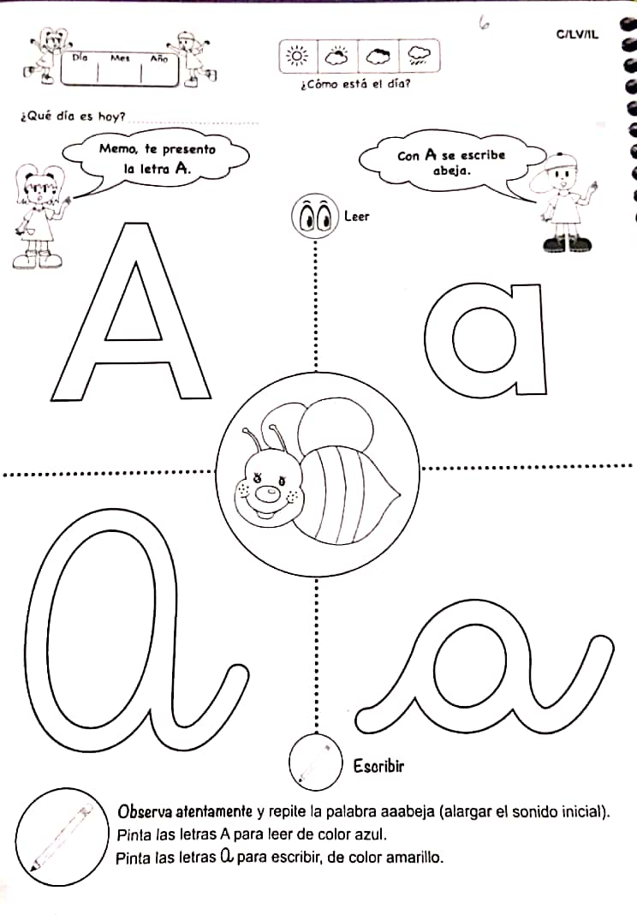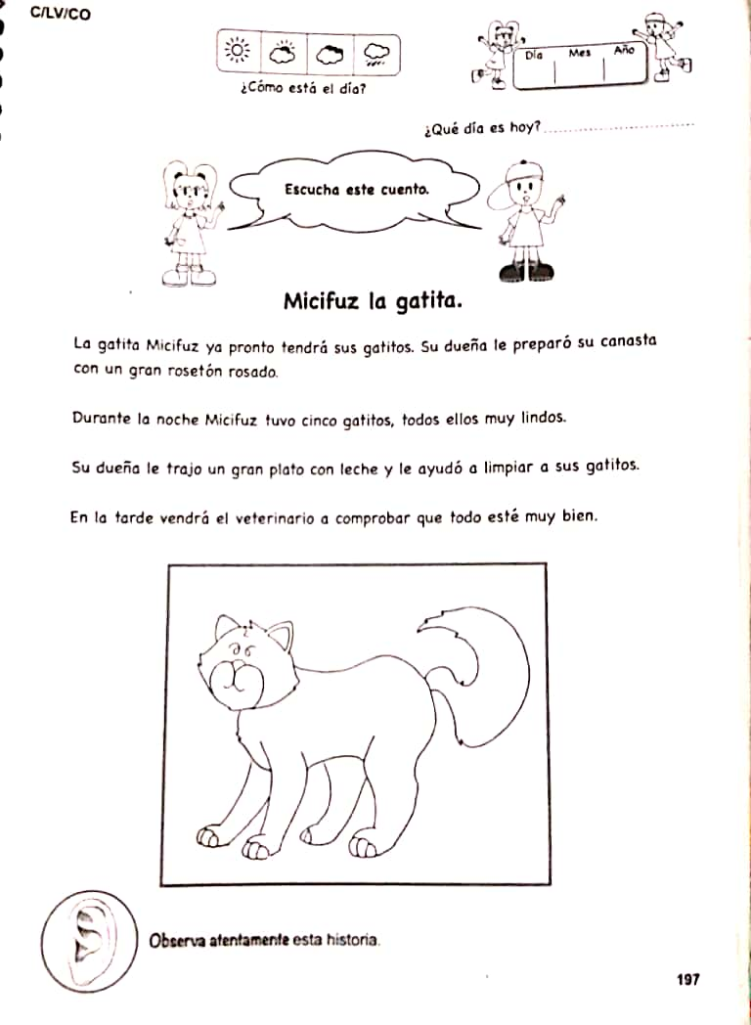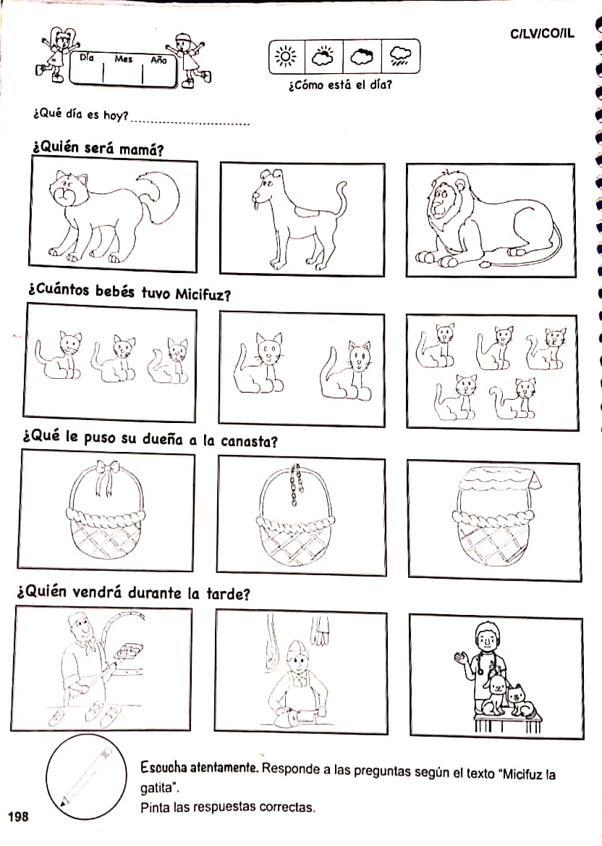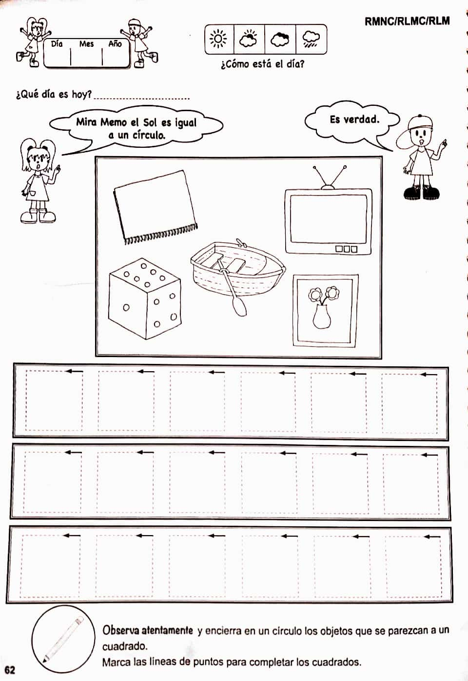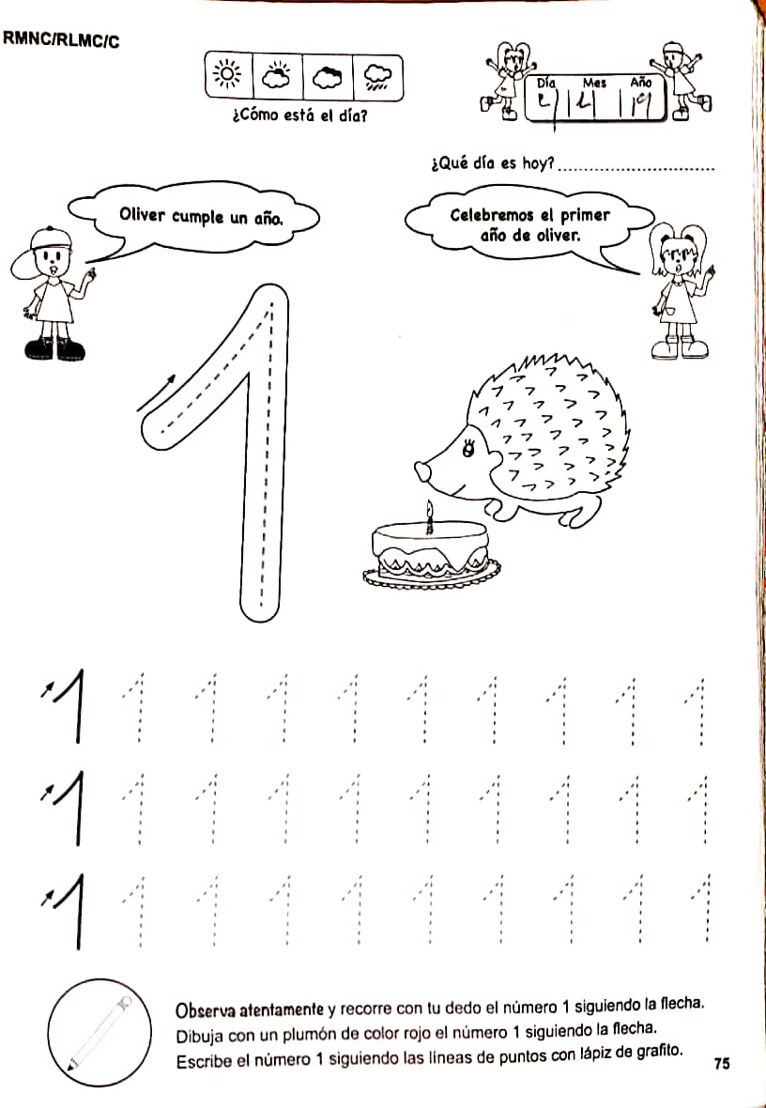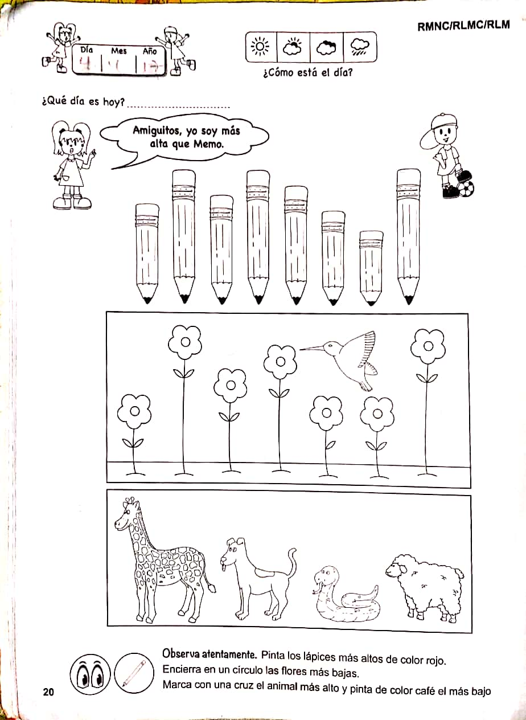

LUNES 27 PRE-KINDER

MIERCOLES 29 PRE KINDER -KINDER

MIERCOLES 29 PRE-KINDER-KINDER

JUEVES 30 PRE-KINDER

MIERCOLES 29 PRE--KINDER

LUNES 27 KINDER

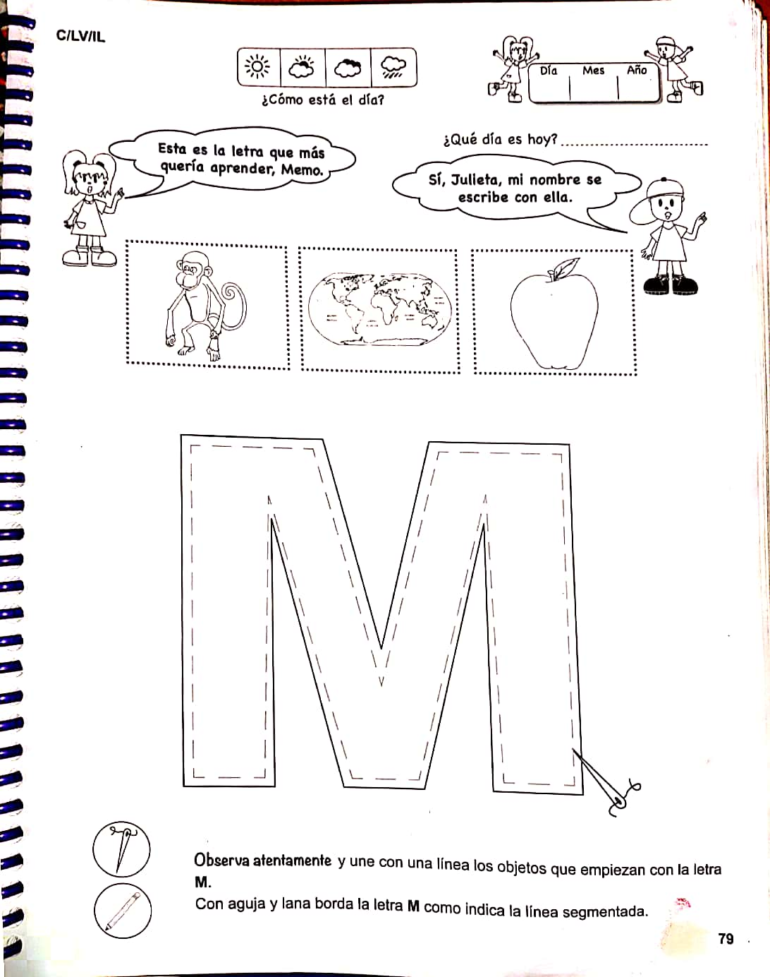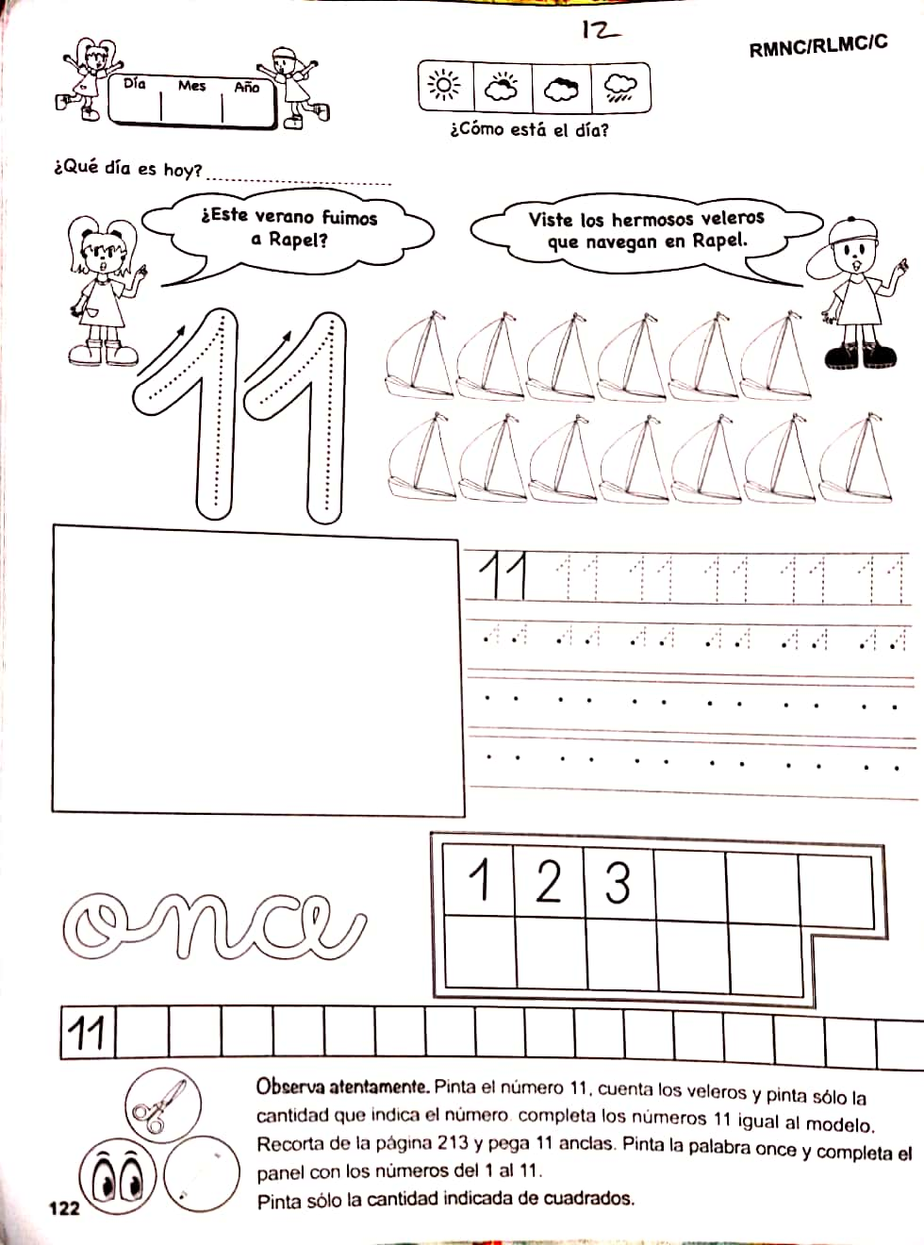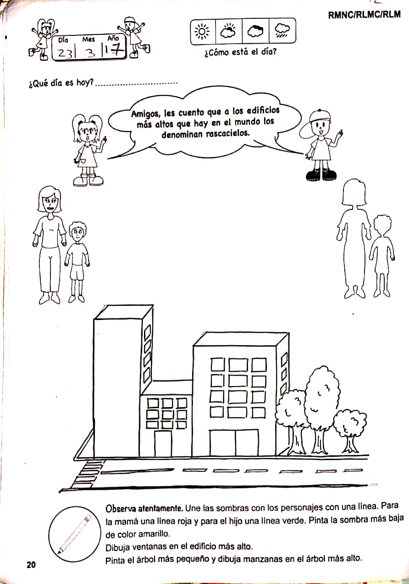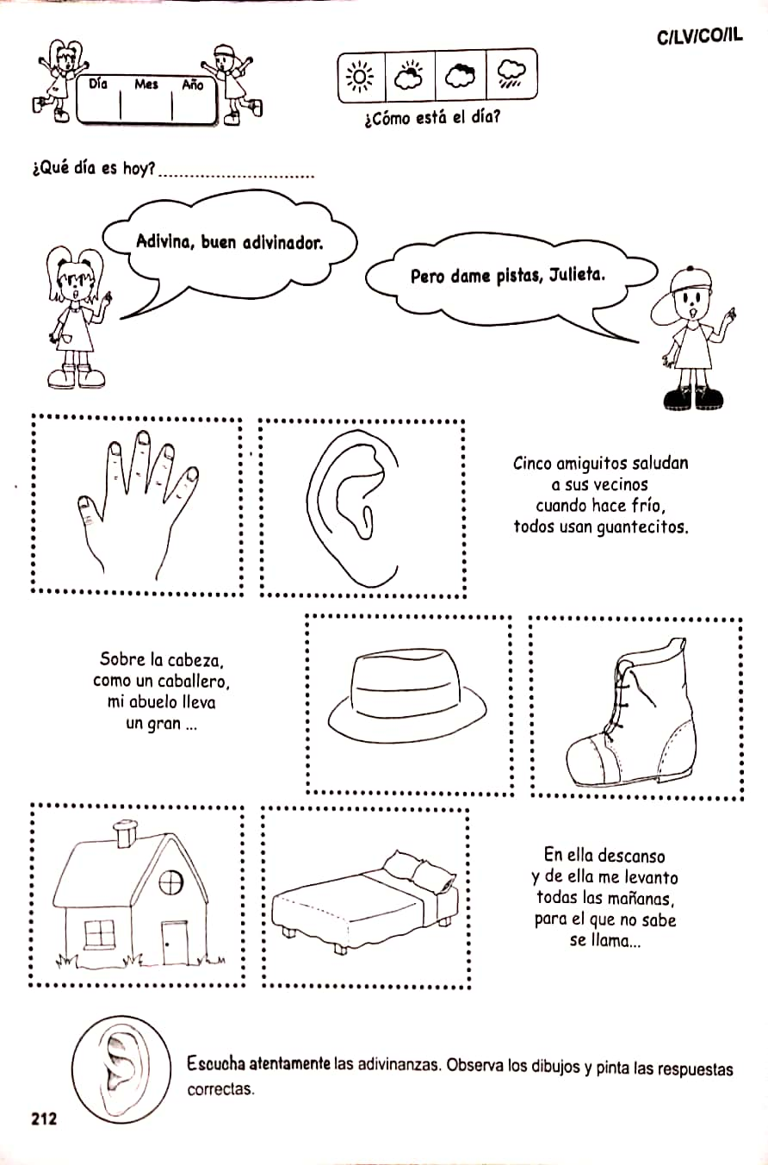

LUNES 27 KINDER

MIERCOLES 29 KINDER

LUNES 27 PRE-KINDER

JUEVES 30 PRE-KINDER KINDER

LUNES 27 PRE-KINDER